**Setup Master-Slave DNS Server Using “Bind” Tools**

**Domain Name Server** (DNS) used for name resolving to any hosts. Master DNS servers (**Primary Server**) are the original zone data handlers and Slave DNS server (**Secondary Server**) are just a backup servers which is used to copy the same zone information’s from the master servers. Master Server will resolve the names for every hosts which we defined in the zone database and use UDP protocol, because UDP protocols never use the acknowledgement process while tcp uses acknowledgement. DNS servers also use UDP protocols to resolve the query request at the earliest.

I’m using 3 machines, 2 for server setup (master and slave) and 1 for client.

---------------------------------------------------

**Master DNS Server**

---------------------------------------------------

IP Address : 192.168.0.200

Host-name : masterdns.tecmintlocal.com

OS : Centos 6.5 Final

---------------------------------------------------

**Slave DNS Server**

---------------------------------------------------

IP Address : 192.168.0.201

Host-name : slavedns.tecmintlocal.com

OS : Centos 6.5 Final

---------------------------------------------------

**Client Machine to use DNS**

---------------------------------------------------

IP Address : 192.168.0.210

Host-name : node1.tecmintlocal.com

OS : Centos 6.5 Final

### Setup Master DNS ServerFirst, verify the IP address, Hostname and Distribution version of Master DNS Server, before moving forward for setup.

$ sudo ifconfig | grep inet

$ hostname

$ cat /etc/redhat-release

Once, you confirm that the above settings are correct, its time to move forward to install required packages.

$ sudo yum install bind* -y

#### Installing and Configuring Bind

After installing required packages, now define zone files in master configuration ‘**named.conf**‘ file.

$ sudo vim /etc/named.conf

iven below is my **named.conf** file entry, change the configuration file as per your need.

//

// named.conf

//

// Provided by Red Hat bind package to configure the ISC BIND named(8) DNS

// server as a caching only nameserver (as a localhost DNS resolver only).

//

// See /usr/share/doc/bind*/sample/ for example named configuration files.

//

options {

listen-on port 53 { **127.0.0.1; 192.168.0.200**; }; # Here we need to add our Master DNS Server IP.

listen-on-v6 port 53 { ::1; };

directory "/var/named";

dump-file "/var/named/data/cache_dump.db";

statistics-file "/var/named/data/named_stats.txt";

memstatistics-file "/var/named/data/named_mem_stats.txt";

allow-query { localhost; 192.168.0.0/24; }; # subnet range where my hosts are allowed to query our DNS.

allow-transfer { **localhost; 192.168.0.201**; }; # Here we need to our Slave DNS server IP.

**recursion no**;

dnssec-enable yes;

dnssec-validation yes;

dnssec-lookaside auto;

/* Path to ISC DLV key */

bindkeys-file "/etc/named.iscdlv.key";

managed-keys-directory "/var/named/dynamic";

};

logging {

channel default_debug {

file "data/named.run";

severity dynamic;

};

};

zone "." IN {

type hint;

file "named.ca";

};

## Define our forward & reverse Zone file here for tecmintlocal.com.

zone"**tecmintlocal.com**" IN {

type master;

file "**tecmintlocal.fwd.zone**";

allow-update { none; };

};

zone"**0.168.192.in-addr.arpa**" IN {

type master;

file "**tecmintlocal.rev.zone**";

allow-update { none; };

};

#####

include "/etc/named.rfc1912.zones";

include "/etc/named.root.key";

#### Creating Master Zone Files

At first let us define forward look-up zone entry. Here we need to create the zone files in the name of what we have define in the **named.conf** file as below.

tecmintlocal.fwd.zone

tecmintlocal.rev.zone

We use sample configuration files for creating forward zone files, for this we’ve to copy the sample configuration files.

$ sudo cp /var/named/named.localhost /var/named/tecmintlocal.fwd.zone

$ sudo cp /var/named/named.loopback /var/named/tecmintlocal.rev.zone

Once, you’ve copied configuration files, now edit these zones files using **vim** editor.

$ sudo vim /var/named/tecmintlocal.fwd.zone

This is my forward zone configuration, append the below entry and make changes as per your need.

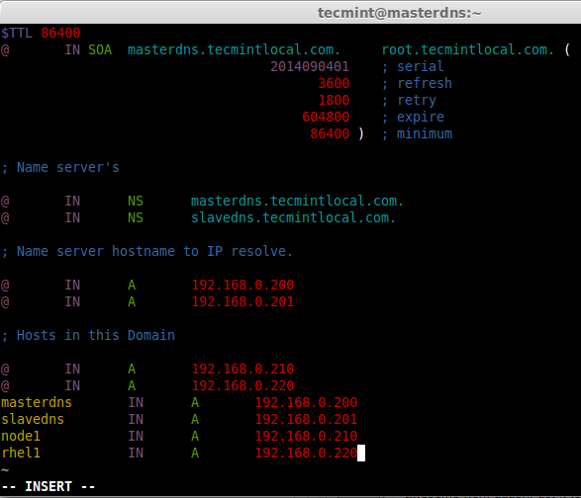

Now, create reverse lookup file, we have already made a copy of loop-back file in the name of **tecmintlocal.rev.zone**. So, we use this file to configure our reverse look-up.

$ sudo vim /var/named/tecmintlocal.rev.zone

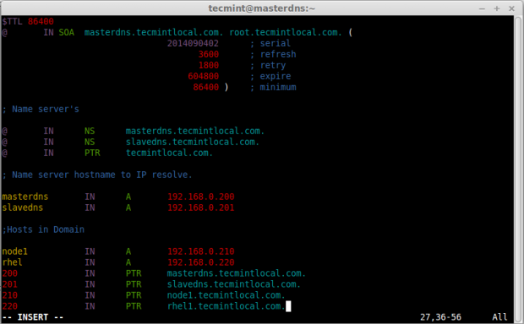

Check the group ownership of forward look-up & reverse look-up files, before checking for any errors in configuration.

$ sudo ls -l /var/named/

Here we can see both the files are in **root** users ownership, because files which we makes a copy from sample files are available under **/var/named/**. Change the group to named on both files using following commands.

$ sudo chgrp named /var/named/tecmintlocal.fwd.zone

$ sudo chgrp named /var/named/tecmintlocal.rev.zone

After setting correct ownership on the files, verify them again.

$ sudo ls -l /var/named/

Now, check for the errors in zone files, before starting the DNS service. First check the **named.conf** file, then check other zone files.

$ sudo named-checkconf /etc/named.conf

$ sudo named-checkzone masterdns.tecminlocal.com /var/named/tecmintlocal.fwd.zone

$ sudo named-checkzone masterdns.tecminlocal.com /var/named/tecmintlocal.rev.zone

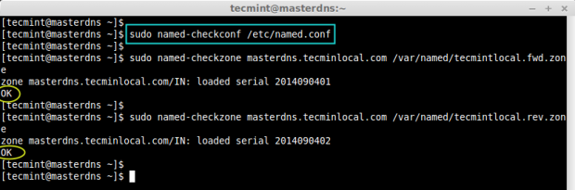

By default iptables was running and our DNS server is restricted to localhost, if client wants to resolve name from our DNS Server, then we have to allow the inbound request, for that we need to add iptables inbound rule for the port 53.

$ sudo iptables -I INPUT -p udp --dport 53 -m state --state NEW -j ACCEPT

Now, verify that the rules has been added correctly in **INPUT** chain.

$ sudo iptables -L INPUT

Next, save the rules and restart firewall.

$ sudo service iptables save

$ sudo service iptables restart

[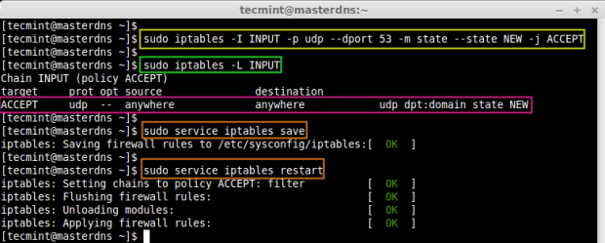](http://www.tecmint.com/wp-content/uploads/2014/09/Open-DNS-Port-on-Firewall.png)

Start the named service and make it persistent.

$ sudo service named start

$ sudo chkconfig named on

$ sudo chkconfig --list named

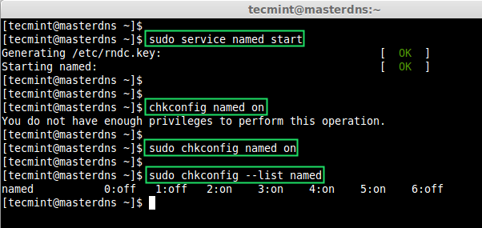

Finally, test the configured Master DNS zone files (forward and reverse), using **dig** & **nslookup** tools.

$ dig masterdns.tecmintlocal.com

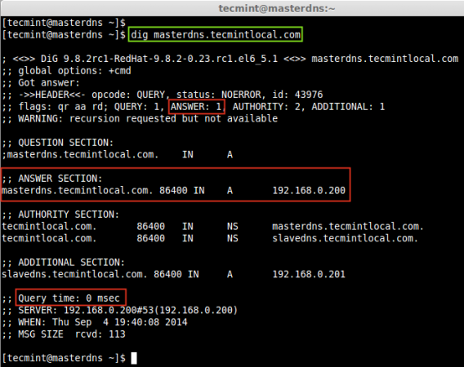

$ dig -x 192.168.0.200

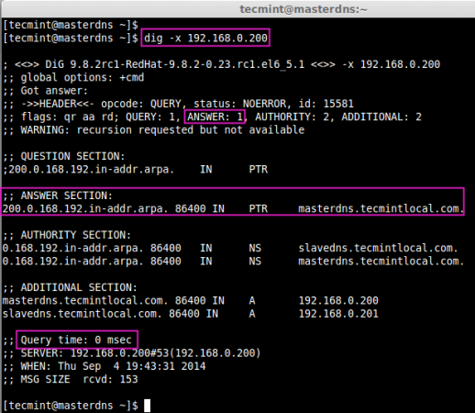

$ nslookup tecmintlocal.com

$ nslookup masterdns.tecmintlocal.com

$ nslookup slavedns.tecmintlocal.com

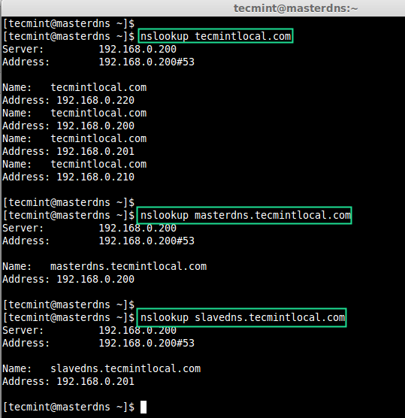

### Setup Slave DNS Server

In Slave machine, also we need to install same bind packages as shown in Master, so let’s install them using following command.

$ sudo yum install bind* -y

Open and edit ‘**named.conf’** file for our zone database and port listen.

$ sudo vim /etc/named.conf

Make changes as shown, as per your requirements.

//

// named.conf

//

// Provided by Red Hat bind package to configure the ISC BIND named(8) DNS

// server as a caching only nameserver (as a localhost DNS resolver only).

//

// See /usr/share/doc/bind*/sample/ for example named configuration files.

//

options {

listen-on port 53 { **127.0.0.1; 192.168.0.201**}; # Our Slave DNS server IP

listen-on-v6 port 53 { ::1; };

directory "/var/named";

dump-file "/var/named/data/cache_dump.db";

statistics-file "/var/named/data/named_stats.txt";

memstatistics-file "/var/named/data/named_mem_stats.txt";

allow-query { **localhost; 192.168.0.0/24**; };

**recursion no**;

dnssec-enable yes;

dnssec-validation yes;

dnssec-lookaside auto;

/* Path to ISC DLV key */

bindkeys-file "/etc/named.iscdlv.key";

managed-keys-directory "/var/named/dynamic";

};

logging {

channel default_debug {

file "data/named.run";

severity dynamic;

};

};

zone "." IN {

type hint;

file "named.ca";

};

## Define our slave forward and reverse zone, Zone files are replicated from master.

zone"**tecmintlocal.com**" IN {

type slave;

file "**slaves/tecmintlocal.fwd.zone**";

masters { **192.168.0.200**; };

};

zone"**0.168.192.in-addr.arpa**" IN {

type slave;

file "**slaves/tecmintlocal.rev.zone**";

masters { **192.168.0.200**; };

};

#####

include "/etc/named.rfc1912.zones";

include "/etc/named.root.key";

Start the DNS service using.

$ sudo service named start

After restarting the bind service, we don’t have to define the zone information individually, as our **allow-transfer** will replicate the zone information from master server as shown in the image below.

$ sudo ls -l /var/named/slaves

Verify, the zone information using cat command.

$ sudo cat /var/named/slaves/tecmintlocal.fwd.zone

$ sudo cat /var/named/slaves/tecmintlocal.rev.zone

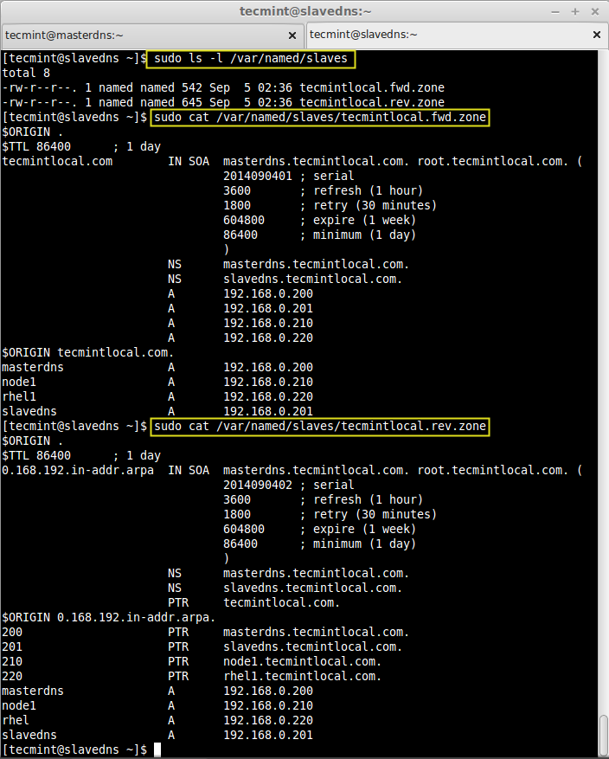

Next, open DNS port **53** on iptables to allow inbound connection.

$ sudo iptables -I INPUT -p udp --dport 53 -m state --state NEW -j ACCEPT

Save the iptables rules and restart the iptables service.

$ sudo service iptables save

$ sudo service iptables restart

Make the service persistent on system boot.

$ sudo chkconfig iptables on

Check whether persistent set for run-levels .

$ sudo chkconfig --list iptables

[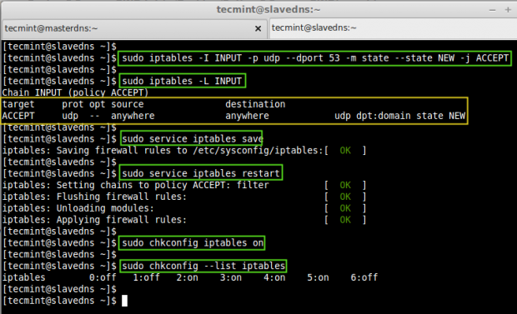](http://www.tecmint.com/wp-content/uploads/2014/09/Open-DNS-Port.png)

### Configure Client Machine

In client side we need to assign the Primary (**192.168.0.200**) and Secondary DNS (**192.168.0.201**) entry in network settings to get assign a hostname. To do, run the setup command to define all these entries as shown in the picture

$ setup

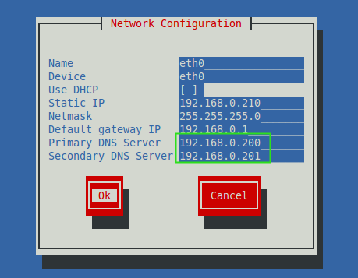

Else, edit the ‘**/etc/reslov.conf**‘ file and add the following entries.

$ vim /etc/resolv.conf

search tecmintlocal.com

nameserver 192.168.0.200

nameserver 192.168.0.201

Now, verify the ip, hostname and name server look-up.

$ ifconfig | grep inet

$ hostname

$ nslookup tecmintlocal.com

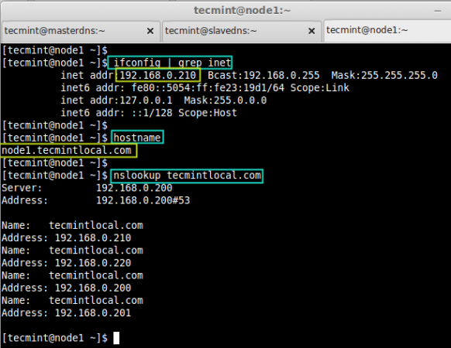

Now, check the forward & Reverse DNS look-up using.

$ dig masterdns.tecmintlocal.com

$ dig -x 192.168.0.200

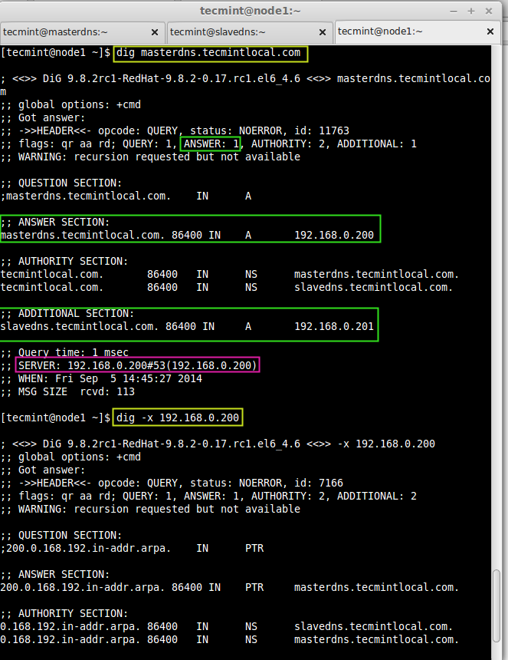

Finally check for our node and make a ping.

$ dig node1.tecmintlocal.com

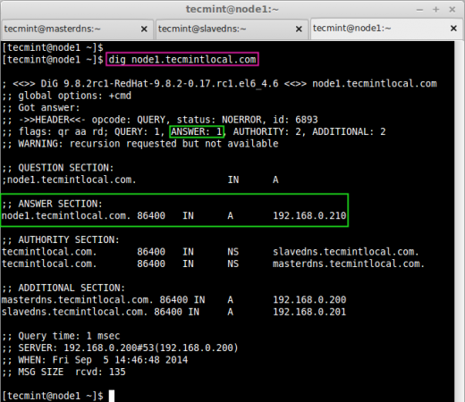

$ ping masterdns.tecmintlocal.com -c 2

$ ping slavedns.tecmintlocal.com -c 2

$ ping 192.168.0.200 -c 2

$ ping 192.168.0.201 -c 2

Finally, setup completed, here we have configured both Primary (Master) and Slave (Seconday) DNS server successfully,